Visit https://www.noip.com
Create hostname by creating a name and suffix, from the dropdown listing, then click Sign Up. (WMCUser, in the image below was just a test account. You can use any name you want.)
Please be aware that the default suffix is hopto.org with ddns.net being an option in the dropdown.

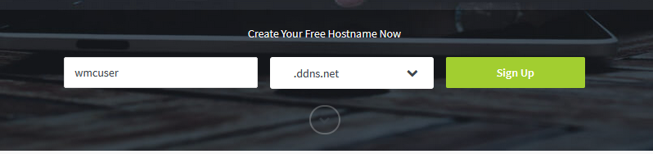
Create your FREE account by entering your email, either personal or college address, and a password. Tick the Terms of Service box (highlighted) and click on Free Sign Up (arrowed).

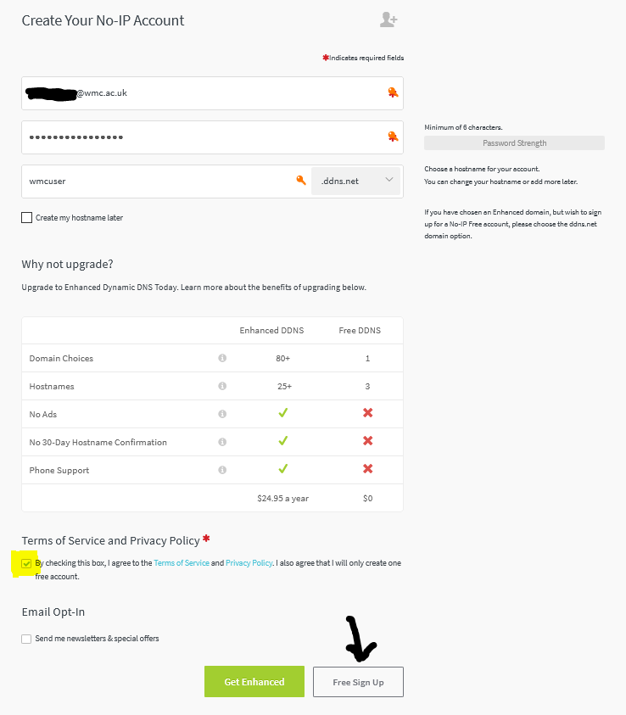
Sign into the email account you used, to register, and Confirm Account through the email they sent. If you are using webmail then you will need to right click Confirm Account and select Open link in a new tab.
This will setup the account. You login in with your email address and password.
On the left-hand side is a menu system. Click on Dynamic DNS then Dynamic Update Client.
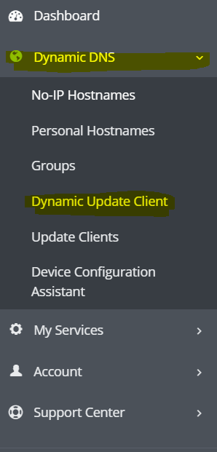
This gives you the option to download the Dynamic Update Client (DUC) for Windows, Mac or Linux. There are apps available for Android and Apple devices.
Select the operating system you using and click the Download DUC button. Once downloaded, open your Downloads folder and run the installer (for Windows – DUCSetup_v4_1_1.exe at time of writing). Accept defaults and make sure the 2 boxes at the end, of the installation, are ticked.

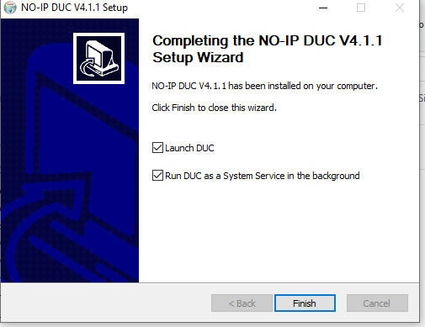

When the software starts up enter your email address and password that you created earlier.
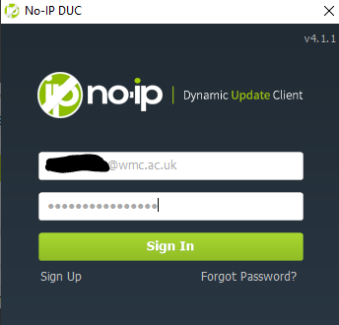
Select the hostname associated with your account and click Save.
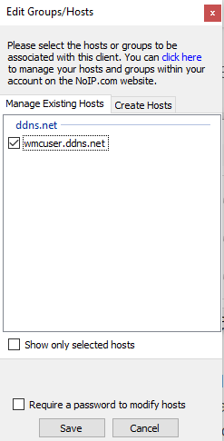
You have now configured your Dynamic DNS Client.

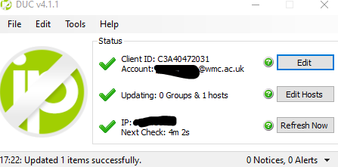
This starts when you boot your computer and updates the servers every 5 minutes.
Email your DDNS hostname to it.team@wmc.ac.uk
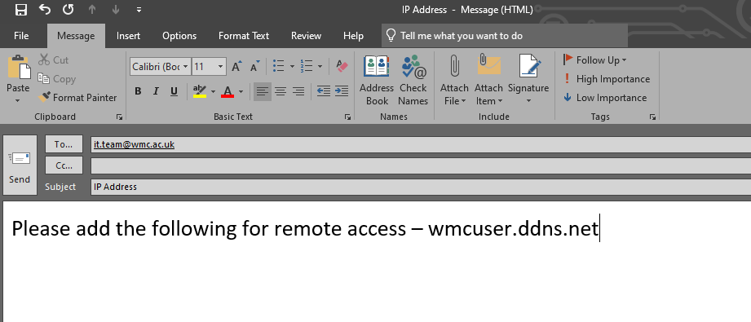
Hopefully this will resolve the issues were your ISP changes your IP address and you lose your access to remote access.
If you visit another home and connect to their WiFi then it can take 5-10 minutes for everything to settle down and give you access to remote access again. This should also help with people using WiFi dongles or visiting external sites and connecting to WiFi.
IMPORTANT
Every 30 days you will receive and email asking you to Confirm Hostname. Click on the link and this will keep the account live.

